**Day 7 - Assignment on KAFKA**

**Kafka commands for Order Processing System**

1. **Starting Zookeeper & Kafka servers:**

* zookeeper-server-start.sh $KAFKA_PATH/config/zookeeper.properties

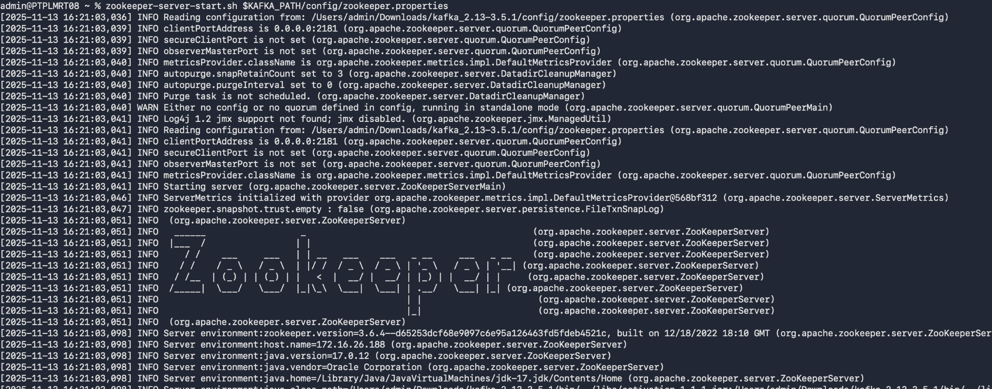

* kafka-server-start.sh $KAFKA_PATH/config/server1.properties

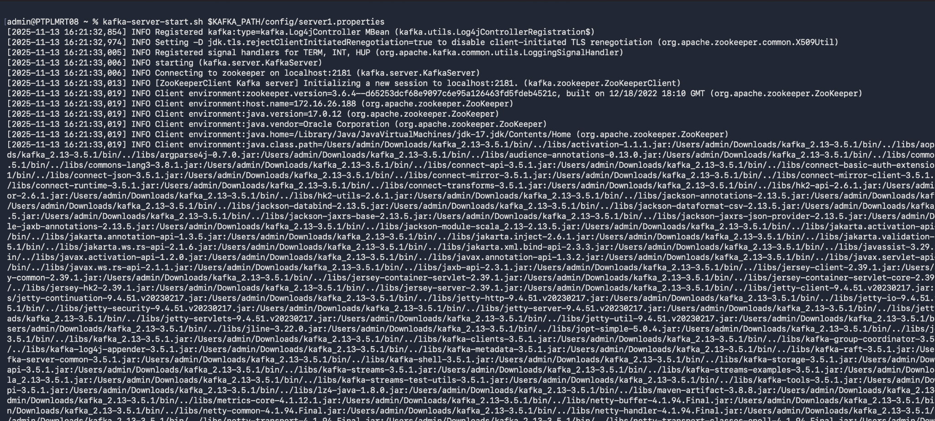

* Similarly to be done for,
* kafka-server-start.sh $KAFKA_PATH/config/server2.properties
* kafka-server-start.sh $KAFKA_PATH/config/server3.properties

2. After the servers have started now we have to create topics

* $KAFKA_PATH/bin/kafka-topics.sh --create --topic orders --bootstrap-server localhost:9092 --partitions 3 --replication-factor 2

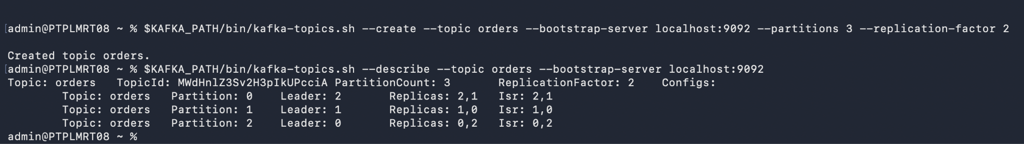

* $KAFKA_PATH/bin/kafka-topics.sh --describe --topic orders --bootstrap-server localhost:9092

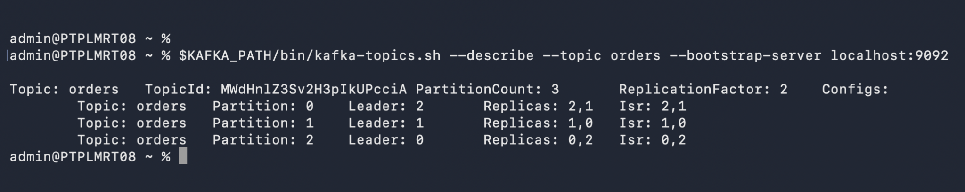

* $KAFKA_PATH/bin/kafka-topics.sh --list --bootstrap-server localhost:9092

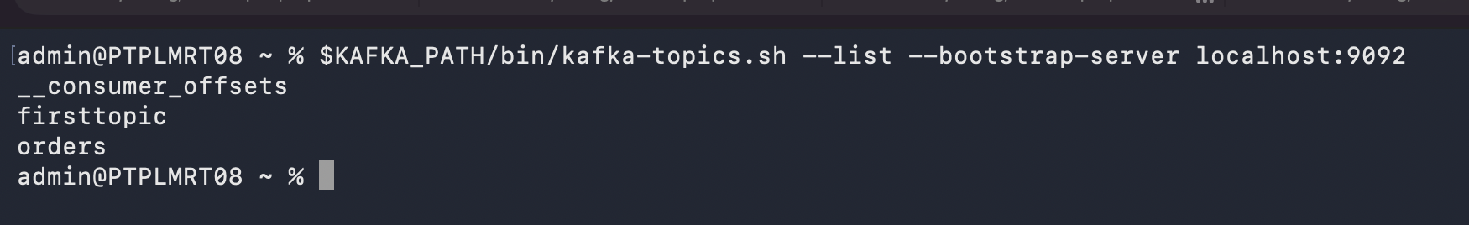

3. Produce Messages:

* $KAFKA_PATH/bin/kafka-console-producer.sh --topic orders --bootstrap-server localhost:9092

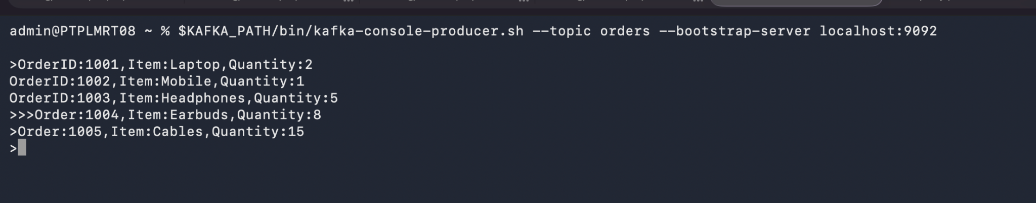

4. Consume Messages:

* $KAFKA_PATH/bin/kafka-console-consumer.sh --topic orders --from-beginning --bootstrap-server localhost:9092 --property print.partition=true --property print.offset=true

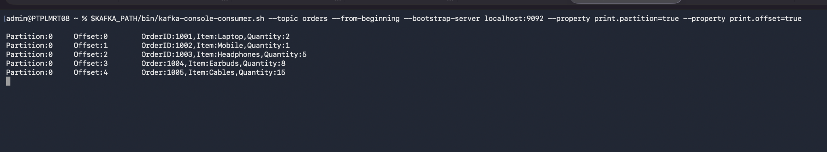

5. Using Consumer Group:

* $KAFKA_PATH/bin/kafka-console-consumer.sh --topic orders --group retailGroup --bootstrap-server localhost:9092
* Terminal 1, consuming the message as they are produced.

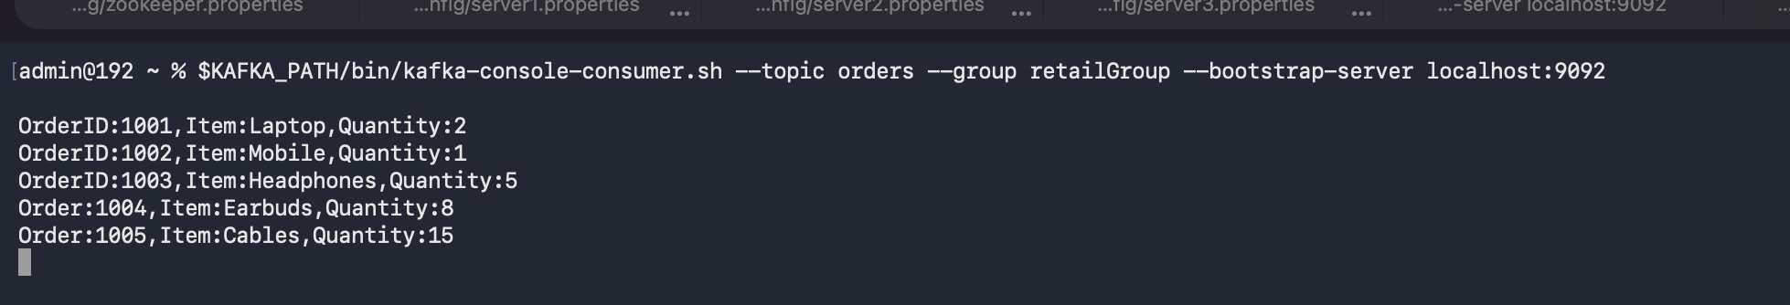

* Terminal 2, not consuming messages as Kafka ensures each partition is consumed by only one consumer within the same group. Terminal 1 consumer is already consuming message that’s why Terminal 2 consumer didn’t receive any message because it belong to same consumer group.

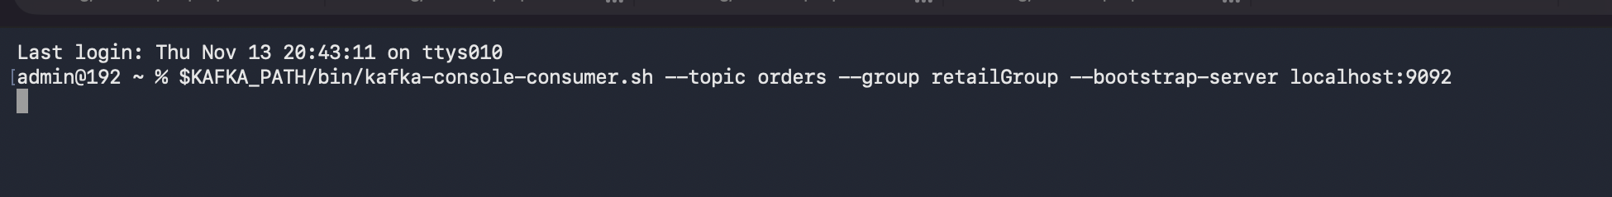

* Consumer Group list;
* $KAFKA_PATH/bin/kafka-consumer-groups.sh --bootstrap-server localhost:9092 --list

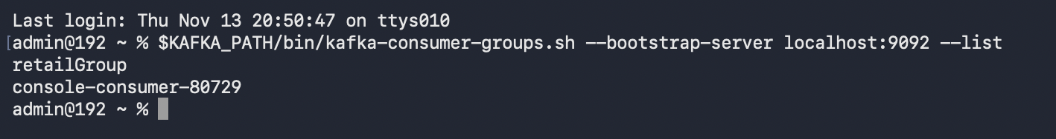

* Describing consumer group:
* $KAFKA_PATH/bin/kafka-consumer-groups.sh --bootstrap-server localhost:9092 --describe --group retailGroup



6. Exploring Message keys:

* Producing messages with keys
* $KAFKA_PATH/bin/kafka-console-producer.sh --topic orders --property parse.key=true --property key.separator=: --bootstrap-server localhost:9092



* Consumer with partition info:
* KAFKA_PATH/bin/kafka-console-consumer.sh --topic orders --from-beginning --bootstrap-server localhost:9092 --property print.partition=true --property print.offset=true

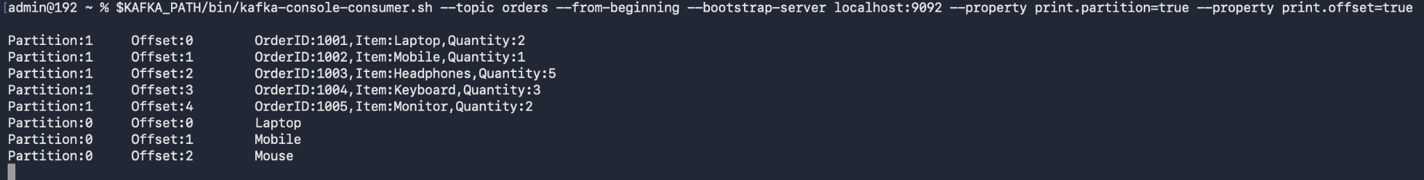

7. Exploring Replication Factor:

* Describing topic order to see leader and replica
* $KAFKA_PATH/bin/kafka-topics.sh --describe --topic orders --bootstrap-server localhost:9092

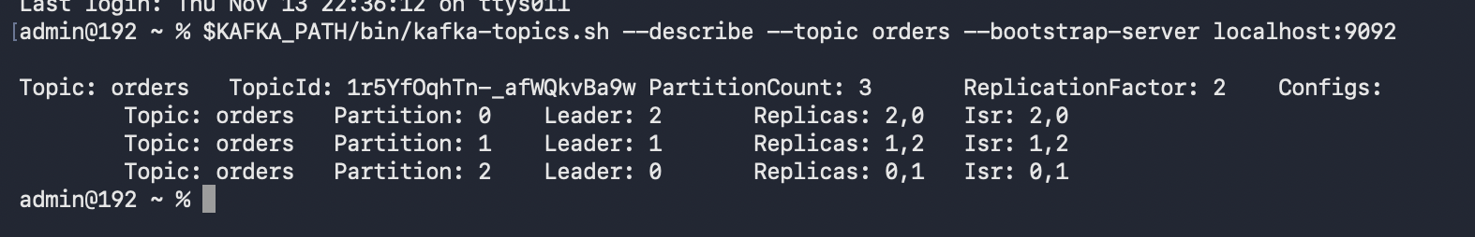

* After stopping one of the broker
* kafka-server-stop.sh $KAFKA_PATH/config/server3.properties
* Checking for changes in the leadership and replica

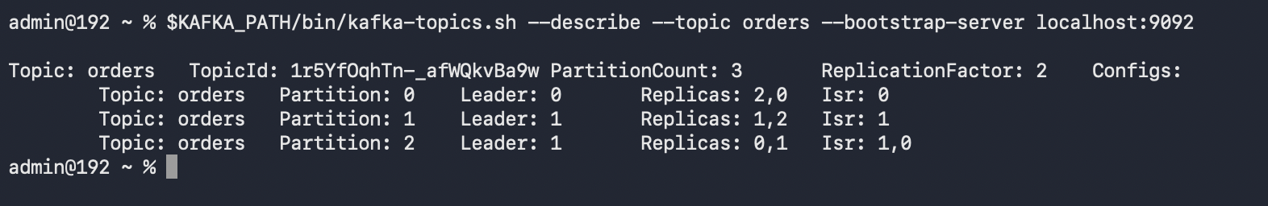

8. Cleanup;

* Deleting topic **orders**
* $KAFKA_PATH/bin/kafka-topics.sh --delete --topic orders --bootstrap-server localhost:9092

